Data Engineering – Data Pipeline and Processing/Visualization Project

# **Basic Architecture Model**

**Contributor:** *Chinmoy Sarangi*



**Tools used to implement the Data Pipeline and Visualize the Analysis:**

Database: *MongoDB*

Programming Language: *Python programming with Jupyter Notebook*

Libraries implemented: *Pandas, PyMongo, Bokeh, Matplotlib, Seaborn, etc.*

**Data Ingestion:**

**Contributor:** *Chinmoy Sarangi*

*Steps Taken:*

The trips files were first attempted to be read directly from the NYC Taxi trips dataset page. This was done to ensure that we were always reading correct data. This is because, in the past, the NYC taxi commission has made corrections to the datasets to fix certain attributes or the data entries and introduce some new features due to addition of new surcharges.

The file access was achieved via Python Pandas which provided us ample amount of information on how the data looked like, without having to access or store the file locally, hence saving disk space. However, we quickly realized that the file sizes were huge, and it took excessively long time to read the data.

Below are the wall times taken when attempting to read directly from the website. The code and time taken to read the files online are as follows:

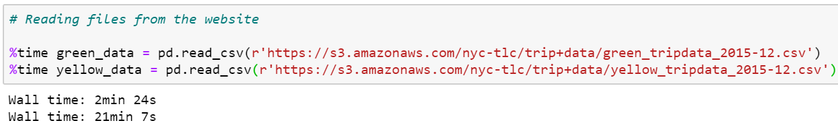.

So, we stored the file locally and the results were dramatically different. The file reading was faster and was done in no time.

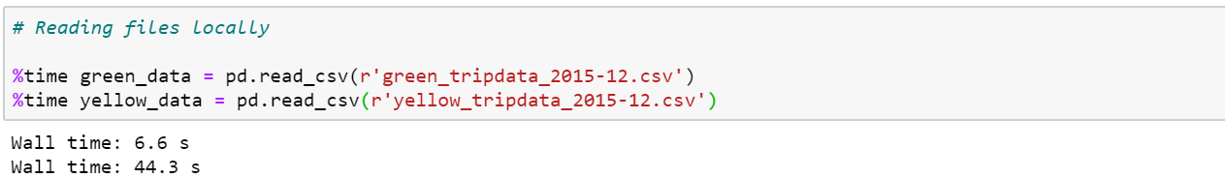

The different wall timings (i.e. the overall time taken for execution of that statement) are due to the size of the datasets.

So, it was clear that the pipeline would have to be implemented with locally stored data in order to reduce the difficulties faced in terms of delayed data import and subsequent rollover on to other processes that follow.

Since the dataset for yellow taxi trips was humongous, hence we chose to go with green taxi trips data, which was significantly smaller in size and easier to manage throughout the rest of the process, right until the visualization stage.

**Data Storage in MongoDB:  
Contributor:** *Chinmoy Sarangi & Gaurang Sharma*

*Steps Taken:*

The data derived from the Python Pandas operation was then exported into the MongoDB using the PyMongo programming.

**1. Initializing MongoDB server and MongoDB Community Compass**

**Contributor:** *Chinmoy Sarangi*

The Mongo instance is executed from the command prompt, which is run with administrator privileges.



The above command line activates mongo with **hostname**: localhost and **port number**: 27017.

After this, launch Mongo Compass Community Edition installed on the system. Below screen with details in grey will open up:

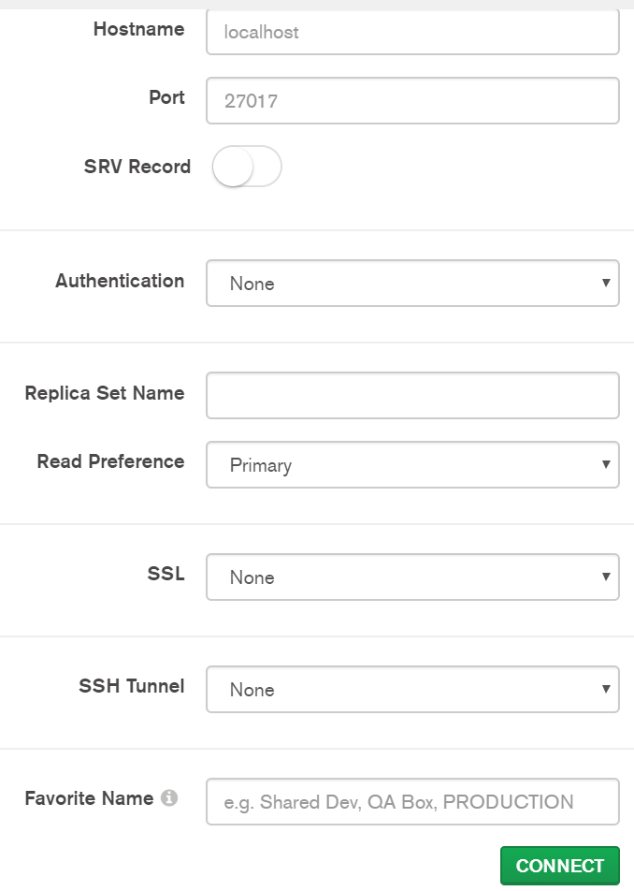

Click on **CONNECT.** This will initiate connection created with above command set.

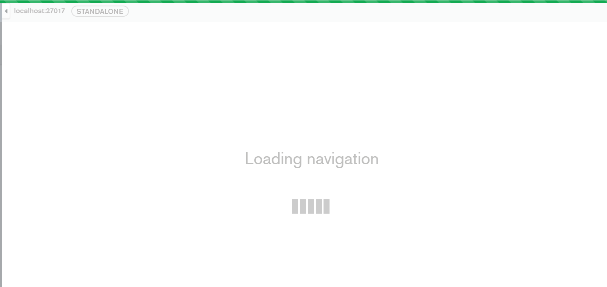

The screen will load with below 3 entries listed as default within the Mongo Compass console:

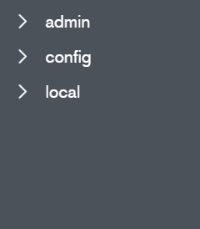

**2. Creating Database and Database Collection:  
Contributor:** *Gaurang Sharma*

By using the PyMongo connection, 1000 rows of sample data were exported to MongoDB from the Pandas DataFrame. The Database name created is: **Taxi_Database**.

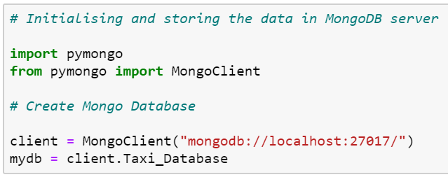

**3. Inserting the Data into Collection:  
Contributor:** *Gaurang Sharma*

But, although a placeholder database may have been created, it does not get recognised until it has collections created within it. Collection name created is - **green_2015_data**.

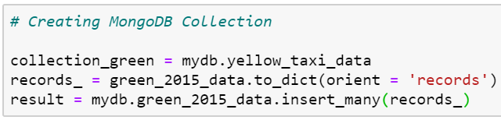

**4. Verifying and Checking Database**

**Contributor:** *Chinmoy Sarangi*

To ensure that the Databases were indeed created, the MongoDB Compass Console was refreshed to verify the same. As can be seen, the above Database and the associated collection for the green taxi trips have been created with 1000 records.

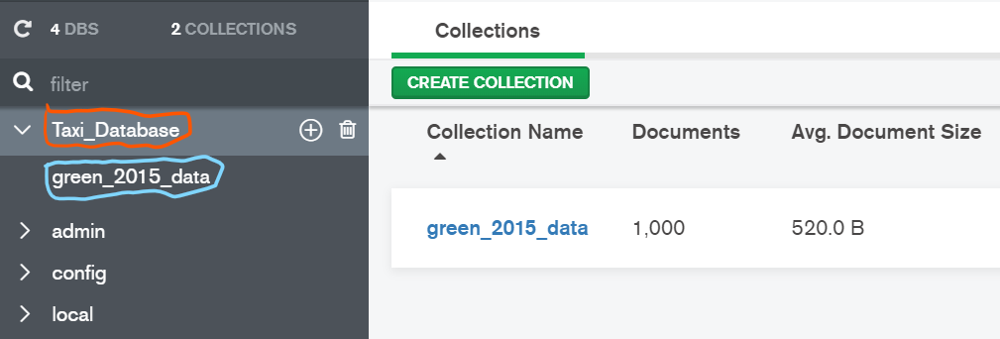

To make sure it is created from Jupyter console, following commands can be run in order to verify the Database and the Collection that were created in the Mongo console earlier:

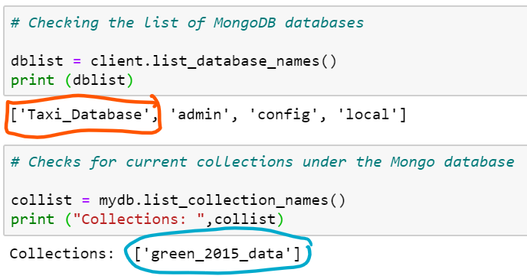

When we click on the collection within MongoDB Compass console, it gives us the data stored.

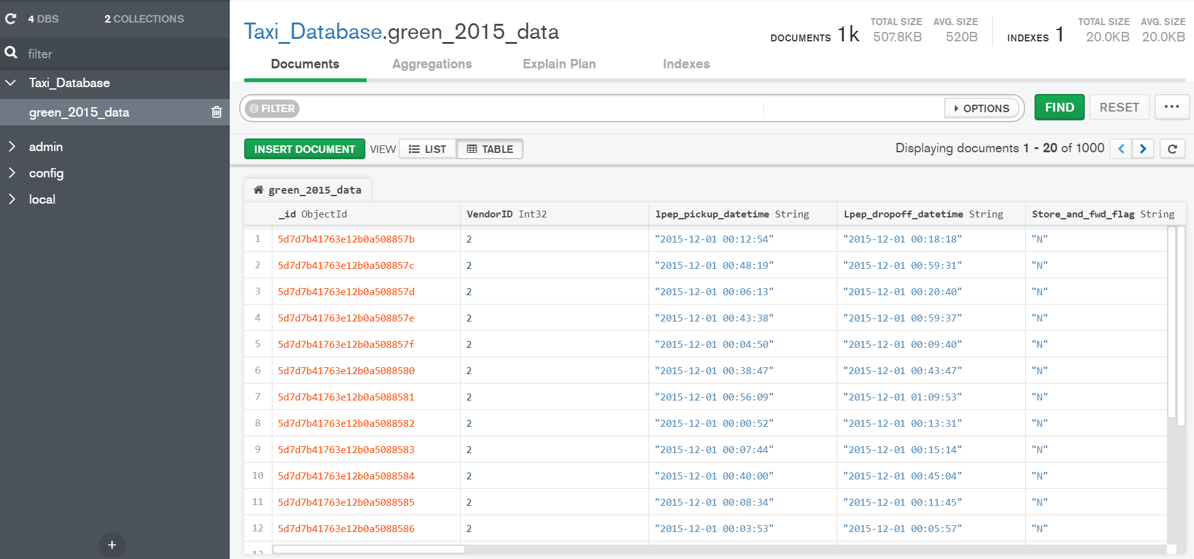

**Data Processing:**

**Contributor:** *Gaurang Sharma & Chinmoy Sarangi*

*Steps Taken:*

As the data is stored in MongoDB now, we use the data further for Processing and Analyzing.

**1. Accessing the store data with Python.   
Contributor:** *Gaurang Sharma*

Loaded the data from the database to Pandas DataFrame as it is easier to process and analyze with Pandas.

**2. Ran some MongoDB queries with PyMongo.   
Contributor:** *Gaurang Sharma & Chinmoy Sarangi*

**3. Tried ‘split’ query with PyMongo.   
Contributor:** *Gaurang Sharma*

We wanted to split date and time from the column, so to easily calculate trip time.

After which we realized that processing is easier and better done with Pandas (datatype = DataFrame) rather than MongoDB (data type = json) queries.

**4. Calculating Trip Time, Average Trip Speed & Extracting Day of the Week with Python.   
Contributor:** *Gaurang Sharma*

Result:

*Time is calculated in minutes and speed in m/s*

**5. Description of each column.**

**Contributor:** *Chinmoy Sarangi & Gaurang Sharma*

*DataFrame.describe()* gives a description of every column, such as count, mean, std, min, max, etc.

|  |  |  |  |  |  |  |  |  |
| --- | --- | --- | --- | --- | --- | --- | --- | --- |
|  | **Fare_amount** | **Passenger_count** | **Tip_amount** | **Tolls_amount** | **Total_amount** | **Trip_distance** | **trip_time** | **trip_speed** |
| **mean** | 10.982500 | 1.371000 | 0.941770 | 0.055400 | 13.236070 | 2.665120 | 17.502000 | inf |
| **min** | -9.000000 | 0.00000 | 1.854485 | 0.551499 | 26.826616 | 5.570901 | 109.124141 | NaN |
| **max** | 826.000000 | 6.000000 | 36.000000 | 5.540000 | 827.300000 | 162.290000 | 1438.000000 | inf |

[Note for Chinmoy: Processing is finished, if we do any more analysis, will add in the end of the day]

**Data Visualization:**

**Contributor:** *Gaurang Sharma*

[Note for Chinmoy: Will add and finish Visualization in some time]

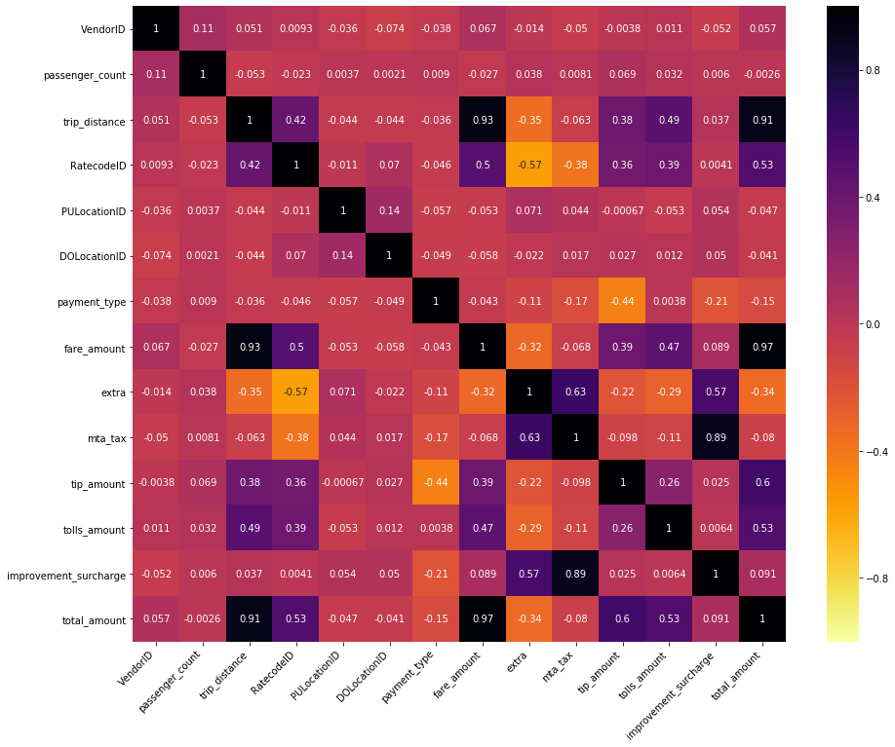

**Ideas:**

What high -level business questions can we answer with our analysis and visualizations? And what could be the newer future ideas?

**Steps done after accessing data from Mongo:**

Perform column splitting before pushing to Mongo.

Perform the join with taxi zone lookup with both yellow and green trip taxis before pushing it to Mongo DB.

**Challenges Encountered**

**Contributor:** *Chinmoy Sarangi and Gaurang Sharma*

* Not only checking for entering unique values, but also accommodate for new entries which are unique in nature instead of random samples which may enter the duplicate entries. This would have been solved with robust resources with more sophisticated systems in place which have capabilities to perform this task of checking for duplicates during the ingestion of the data.
* Issues while reading huge amount of data.
* Docker container could not be implemented due to a series of System crashes post installation.
* Due to lack of more sophisticated systems, unique and fresh data ingestion was challenging.
* Finding absolute queries to link Python and MongoDB reliably. This is because most of the earlier PyMongo codes are in various versions of Python 2.0 iterations, which are incompatible with Python 3 version.
* The newer datasets posted by the NYC Taxi commission do not have latitude and longitude data, starting from January of 2016. Hence, we had to use December 2015 dataset for green taxis in order to achieve faster results and be able to save time for further analysis.
* Also, the newer datasets only had location IDs, which had to be joined with the file containing all the taxi zones in order get the exact pick-up and drop-off locations. The latitude and longitude had to be then derived using the assisting shapefiles, which were uploaded separately.
* Using shapefiles meant, using newer Python libraries called Geopandas and Shapefiles. The output of the shape files in a dataframe was only a single row output with comma separated values in a polygon format, which was challenging to breakdown further.

**Business Questions:  
Contributor:** *Chinmoy Sarangi & Gaurang Sharma*

Where is the highest pickup and drop and what could be the reasons?

What days have highest tip amounts and is it depending on duration/distance?

What could be the rush hours?

Which day/s had the highest number of trips?

Which location has the highest no. of passenger pickups or drop off?

Calculating the trip time.

Are there any anomalies in relation between trip distance/duration and the fare amounts?

**References:**

**Contributor:** *Chinmoy Sarangi and Gaurang Sharma*

**References:**

https://www.youtube.com/watch?v=djfnjtYB2co

https://www.kaggle.com/kerneler/starter-tlc-trip-record-data-029ff9b7-4

https://towardsdatascience.com/data-visualization-with-bokeh-in-python-part-one-getting-started-a11655a467d4

https://pydatascience.org/category/bokeh/

http://zetcode.com/python/pymongo/

https://www.w3schools.com/python/python_mongodb_query.asp

https://www.quora.com/How-can-I-import-a-CSV-file-data-to-MongoDB-using-Python-Flask

https://api.mongodb.com/python/current/tutorial.html

https://docs.mongodb.com/manual/reference/operator/aggregation/abs/

https://www.youtube.com/watch?v=XDAnFZqJDvI

https://www.youtube.com/watch?v=BjlQdOK3n5w -- uses NYC data and bokeh

http://datashader.org/topics/nyc_taxi.html

https://www.kaggle.com/hanriver0618/nyc-taxi-data-exploration-visualization

https://michaeljsanders.com/2017/04/17/python-vlookup.html

https://gis.stackexchange.com/questions/262505/python-cant-read-shapefile

Data Analysis and Map-Reduce with mongoDB and pymongo -- https://av.tib.eu/media/20068

https://medium.com/@jiaminhan/looking-through-the-taxi-meter-analysis-of-the-nyc-green-taxi-data-c1dbe5619afe

https://github.com/JiaminHan/nyc_greentaxi/blob/master/analysis.ipynb

https://stackoverflow.com/questions/25888396/how-to-get-latitude-longitude-with-python

https://developers.google.com/maps/documentation/javascript/get-api-key

https://developers.google.com/maps/documentation/geocoding/intro#RegionCodes

https://docs.scipy.org/doc/numpy-1.13.0/reference/arrays.datetime.html

https://pandas.pydata.org/pandas-docs/stable/reference/api/pandas.to_datetime.html

https://towardsdatascience.com/large-scale-visualizations-and-mapping-with-datashader-d465f5c47fb5